H.T No
Regulations:
A14

Sreenidhi Institute of Science and Technology
(An Autonomous Institution)
Code No: 4F302 Date: 23-Mar-2021(FN)

B.Tech II-Year I- Semester External Examination, March/April-2021 (Supplementary)
Mathematical Foundations of Computer Science (CSE and IT)

Time: 3 Hours Max.Marks:70

Note: a) No additional answer sheets will be provided.
b) All sub-parts of a question must be answered at one place only, otherwise it will not be valued.
c) Missing data can be assumed suitably.

ANSWER ANY 5 OUT OF 8 QUESTIONS. EACH QUESTION CARRIES 14 MARKS.

Bloom's Cognitive Levels of Learning (BCLL)

Remember | L1 | Apply | L3 | Evaluate | L5
Understand | L2 | Analyze | L4 | Create | L6

 |  |  | BCLL | CO(s) | Marks
1. | a) | Check whether the formula is a tautology or a contradiction. | L3 | CO1 | [7M]
 | b) | Obtain the principal conjunctive normal form for | L3 | CO1 | [7M]
2. | a) | Solve the recurrence relation . | L5 | CO2 | [7M]
 | b) | Symbolize the following statements and check for its validity:  All men are mortal, Socrates is a man, Therefore Socrates is a mortal. | L3 | CO2 | [7M]
3. | a) | Let R be a relation on the set defined by Check whether R is an equivalence relation or not. | L2 | CO3 | [7M]
 | b) | Show that is a lattice, where and is the relation of ‘division’. | L2 | CO3 | [7M]
4. | a) | Check whether the set under the operation defined as is an abelian group. | L2 | CO4 | [7M]
 | b) | State and prove Lagrange's theorem. | L5 | CO4 | [7M]
5. | a) | Define spanning tree of a graph G. | L2 | CO5 | [7M]
 | b) | Verify whether the following two graphs G1, G2 are isomorphic or not. Justify your answer.  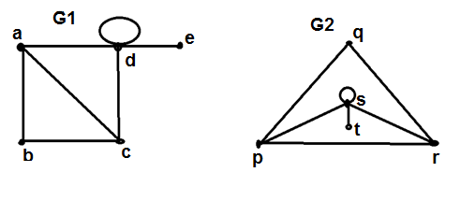 | L4 | CO5 | [7M]
6. | a) | Prove that a complete graph is planar iff | L4 | CO6 | [7M]
 | b) | How many ways 4-digit numbers can be formed with 0,4,5,6,7,8,9, no digit being repeated. | L2 | CO6 | [7M]
7. | a) | Use indirect method to show | L4 | CO1 | [5M]
 | b) | What are free and bound variables? | L2 | CO2 | [5M]
 | c) | Prove that in a lattice, if and only if. | L3 | CO3 | [4M]
8. | a) | Find P(8,4)+P(6,3). | L2 | CO4 | [5M]
 | b) | Is there a graph with degree sequence | L2 | CO5 | [5M]
 | c) | Differentiate between plannar graphs and multi graphs. | L3 | CO6 | [4M]

-- 00 -- 00 –

